**Creating Xamarin Plugin and NuGet Package**

**Geeting Started**:

**Creating Xamarin Plugin**:

1) First make sure NuGet package manager is up to date .

2) Install plugin for Xamarin templates.

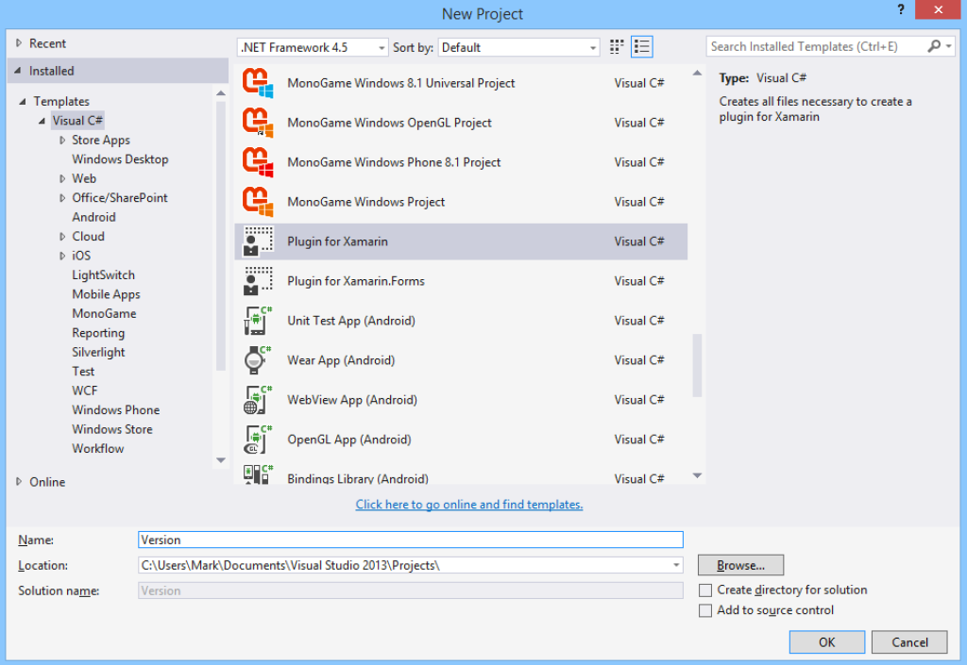

3) Create new project using template "**Plugin for Xamarin**".( It will add two portable library out of which one is abstraction layer and platform specific projects. (**Structure of plugin project**))

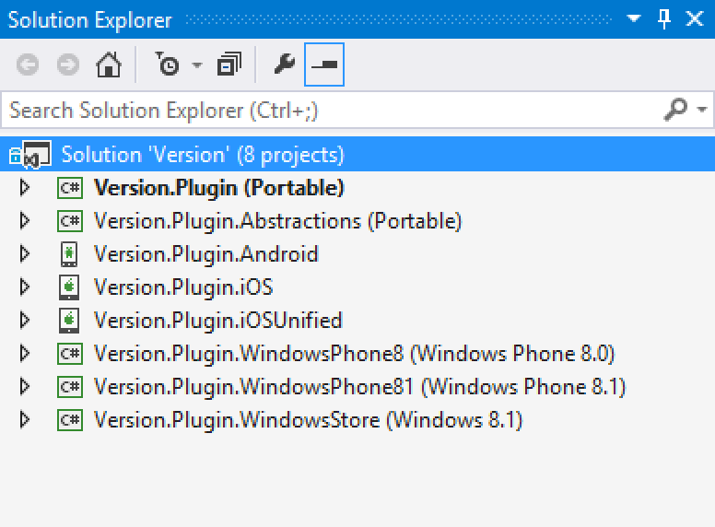

4) Declare the Interface in abstraction portable layer and then implement that interface in all the platform specific projects.

5)Build under release mode.

**Creating NuGet Package**:

1) Create account on NuGet.org.

2) Download NuGet.exe command utility stand alone application and add to your solution root folder (At nuget.org Go to documentation =>Creating and publishing a package section here you will get the steps for the same.)

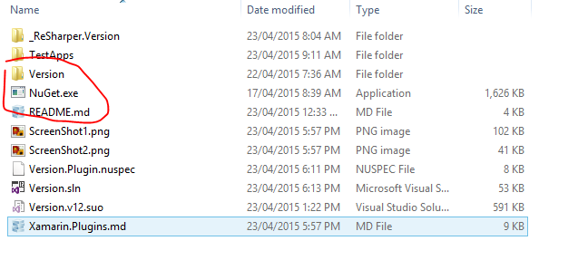

3) Before this you have to add nuspec file I.e. Plugin for Xamarin NuSpec from the templates.

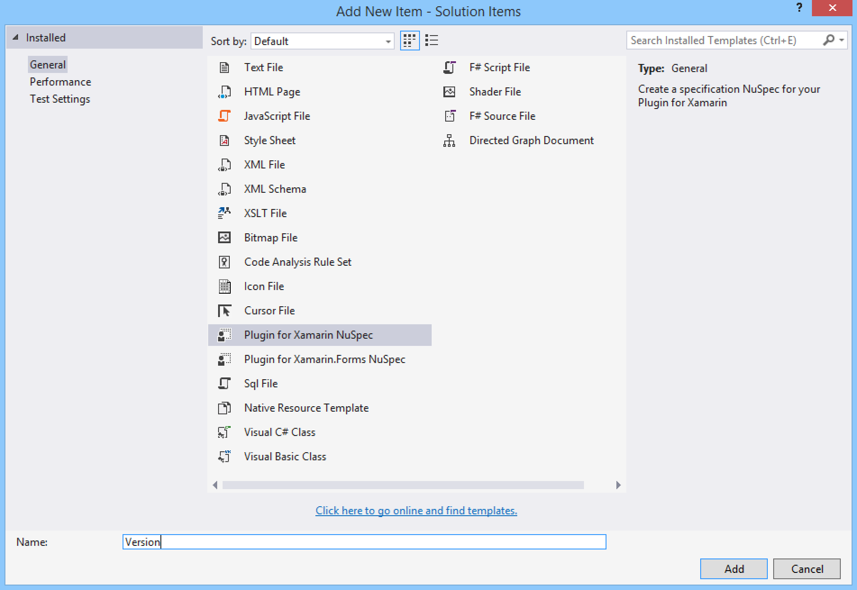

4) You have to fill some information in the XML file like ID, Auther name ,publisher name , project URL(Github URL),brief information ,tags etc

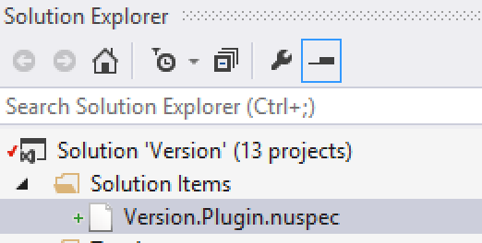

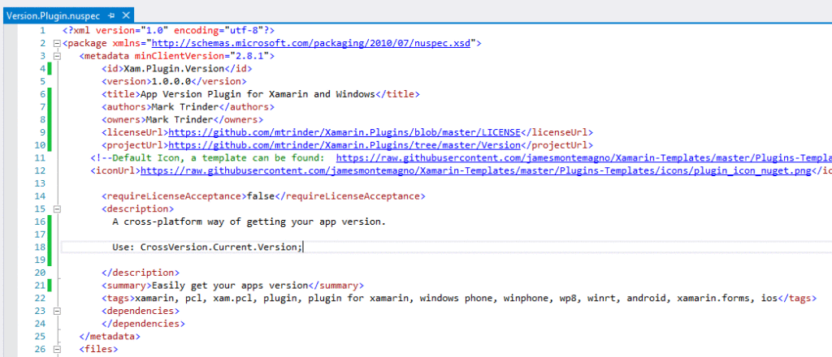

5) Build in release mode and follow the steps under documentation =>Creating and publishing a package.

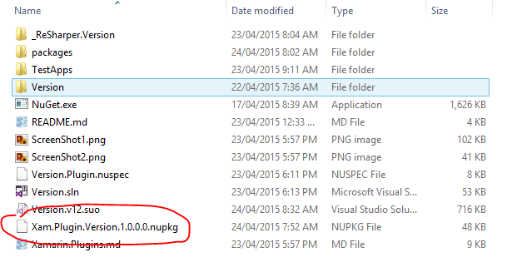

**\* To publish plugin we have to use open source license most popular** **MIT license**.

For reference follow below URL:

https://www.youtube.com/watch?v=eCmgy7TQd00

<https://blog.kloud.com.au/2015/05/12/xamarin-plugins/>